**Blackborough Garden Club - Spring and Early Summer Events**

We have a very interesting year ahead and all our events are open to non-members too. Annual membership is only £10 per person giving free or discounted access to events. Current members please note that subscriptions are now due and early payment (by BACS or cash) is much appreciated so that we can plan ahead.

Be quick – our year starts right now!

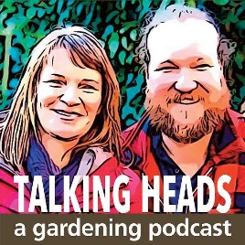**MARCH** **WEDS 5th** TALK 7.30pm Blackborough Village Hall

**Saul Walker (BBC Gardener’s World Live Plant Expert 2025)**

**‘My Life in Horticulture – from plant pots to 16 acres’**

The very knowledgeable and entertaining Saul Walker, head gardener at Stonelands House, Dawlish will be talking about his varied career in horticulture including as a Chelsea Flower Show manager and his time at Kew Gardens.

Q&A session and refreshments. £5 for non-members, members free.

It would be good to welcome Saul with a good turnout for our first event of the year. There will be cake!

**APRIL** AFTERNOON VISIT **The romantic Italian Garden at Great Ambrook, Ipplepen**

**Sunday April 6th** [www.theitaliangarden.org](http://www.theitaliangarden.org) - **‘inspires all who visit’.**

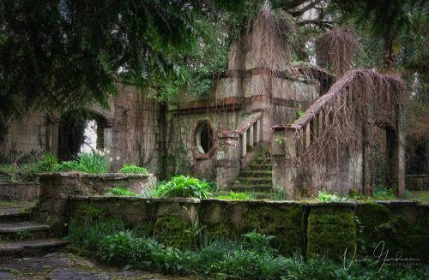

This garden, as featured on BBC Spotlight and in Devon Life magazine (February 2021) has a fascinating history. An extraordinary garden on the edge of Dartmoor, lost for decades…

Completed in 1912 for Arthur Smith Graham and influenced by the Edwardian fashion for Italianate gardens, this remarkable garden had to be designed with refuge and privacy in mind. We will be guided by one of the volunteer garden restoration team who will reveal the secrets of this special place and why it has an important place in social history. There is a YouTube video which gives a good flavour of the garden - search Ipplepen Village - Italian Garden.

This will be a car share visit leaving from Blackborough Village hall car park at 11.30 am and Kentisbeare VH car park (if appropriate) at 11.40am

Planned refreshment stop before the visit at Fermoys Garden Centre.

**Note:** Numbers limited to 12 so please contact Claire Hariades or Andrea Penfold to book a place (see below). Some uneven terrain in the garden.

**MAY**

**Plant sale and coffee morning, Blackborough Village Hall**

**Saturday May 3rd** 10am-12 noon

Plants and produce plus the kick-off for our members’ best begonia and children’s sunflower competitions. Come and claim your free plant /seeds to grow on for the summer show.

**Wednesday May 28th**

Evening visit to Goren Farm Wildflower Meadow and cider orchard

**JUNE DAY COACH TRIP to the** **48th Cerne Abbas Open Gardens and the Cerne Abbas Giant – book now, all welcome**

**Saturday June 14th Departure 10am Return approx. 7.30pm**

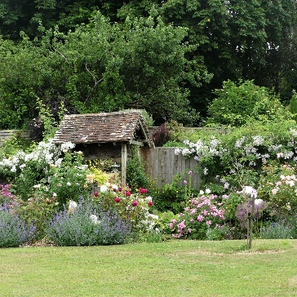

This promises to be a really fun day out. Over 25 Dorset gardens will be open to visit in the beautiful Dorset village of Cerne Abbas, with teas served at the vicarage, three village pubs open, and other village events organised. There will be an opportunity to take a gentle ¼ mile stroll to view the ancient hill carving of the Cerne Abbas giant. Families and club non-members are welcome.

Schedule: Coach picks up at 10am Blackborough Village Hall and 10.15am Kentisbeare VH. Return time approx. 7.30pm

Lunchtime meals may be obtained at one of three pubs in Cerne - the New Inn, The Giant and The Royal Oak, or at the village teashop. The Squibb Garden next to the church is a good place to picnic.

Please reserve a place **asap** by contacting Claire or Andrea (see below) and secured by paying a deposit to cover the coach fare

**Adults £10, Children £5.**

Entry to gardens will be an additional £6 pp (special rate) on the day to allow entry to all 25 gardens. Under-16s free.

Blackborough Garden Club will kindly be subsidising this trip to keep the costs down for all.

More info on the Open Gardens event at:  **http://www.cerneabbasopengardens.org.uk/Pages/Home/Home.aspx**

**Coming up later in the year…**

Summer visits to beautiful local gardens – details to follow

**More information/Bookings/Membership**

Contacts

Claire Hariades [clairehariades@gmail.com](mailto:clairehariades@gmail.com) 07791 538 813

Andrea Penfold [andreappenfold@gmail.com](mailto:andreappenfold@gmail.com)

Gwen Sloman Brown (Treasurer/Memberships) [slomanbrown@btinternet.com](mailto:slomanbrown@btinternet.com)

Jo Talling 266030