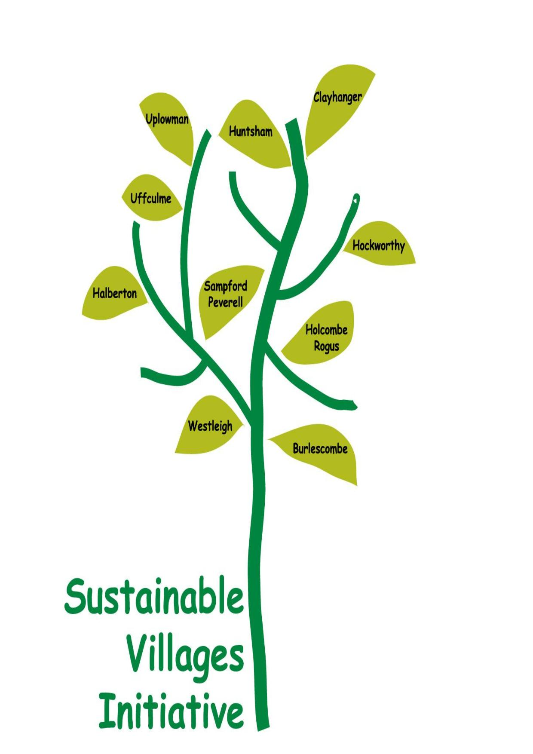
Sustainable Villages presents.......
An audience with
Sir Tim Smit KBE
7.30 pm Wednesday 22nd February
Uffculme High School Hall
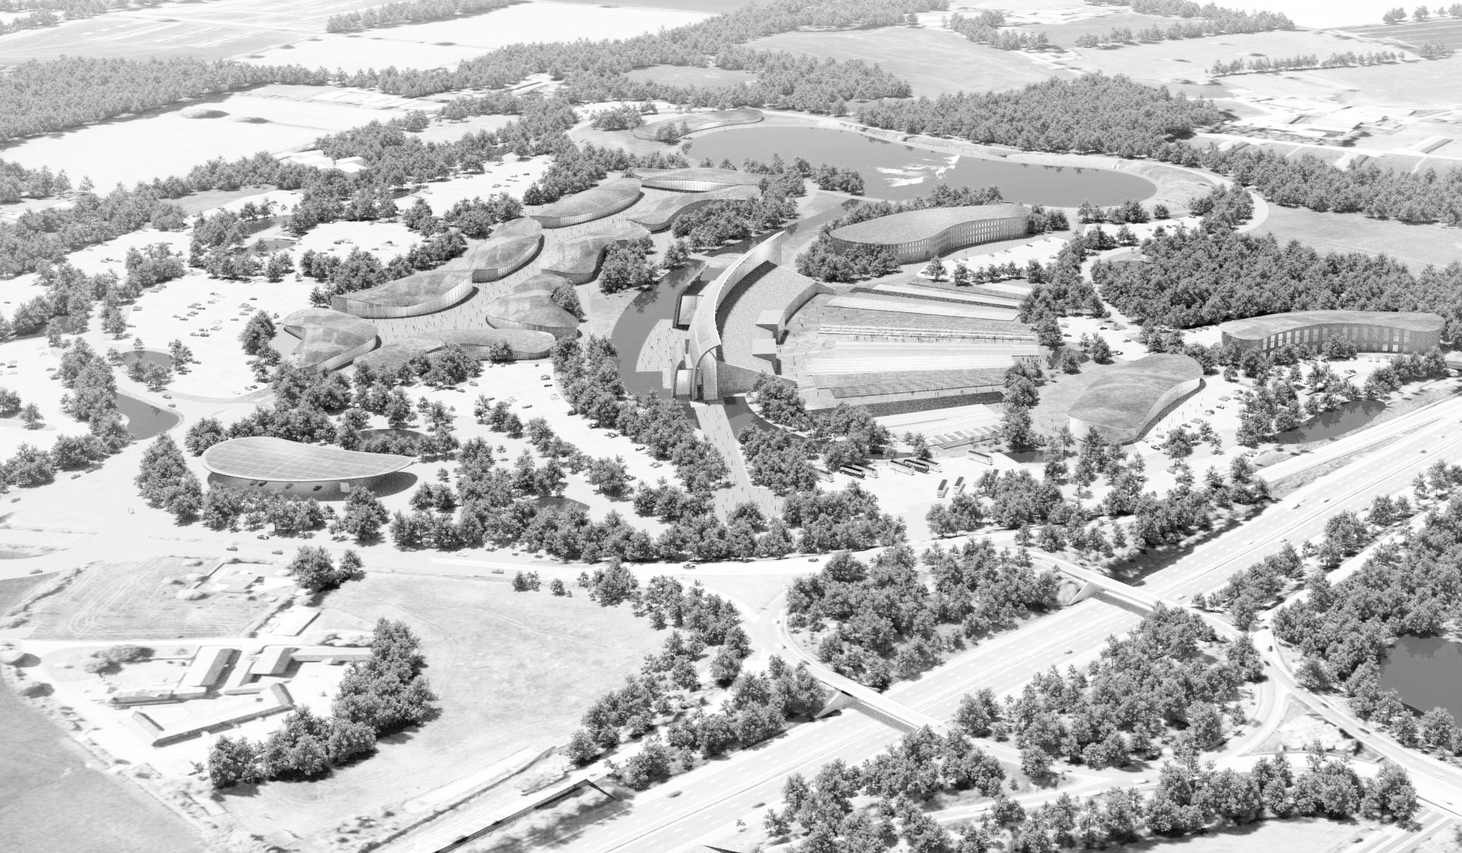
Free Entry, booking advisable – see below
Junction 27 Development

What will be the impact of Eden Westwood on our communities, the environment and the local economy?
Ark or Trojan Horse?

Tickets through Eventbrite https://www.eventbrite.co.uk/

